- Program
#include <stdio.h>
#include <stdlib.h>
#include <omp.h>
#include <time.h>

#define SIZE 100000

// --------------------- MERGE FUNCTION
void merge(int arr[], int left, int mid, int right)
{
int i, j, k;
int n1 = mid - left + 1;
int n2 = right - mid;

int *L = (int *)malloc(n1 * sizeof(int));
int *R = (int *)malloc(n2 * sizeof(int));

for (i = 0; i < n1; i++)
L[i] = arr[left + i];
for (j = 0; j < n2; j++)
R[j] = arr[mid + 1 + j];

i = 0;
j = 0;
k = left;

while (i < n1 && j < n2)
arr[k++] = (L[i] <= R[j]) ? L[i++] : R[j++];

while (i < n1)
arr[k++] = L[i++];

while (j < n2)
arr[k++] = R[j++];

free(L);
free(R);
}

// --------------------- SERIAL MERGE SORT
void serialMergeSort(int arr[], int left, int right)
{
if (left < right)
{
int mid = left + (right - left) / 2;
serialMergeSort(arr, left, mid);
serialMergeSort(arr, mid + 1, right);
merge(arr, left, mid, right);
}
}

// --------------------- PARALLEL MERGE SORT
void parallelMergeSort(int arr[], int left, int right, int depth)
{
if (left < right)
{
int mid = left + (right - left) / 2;

if (depth <= 4)
{
#pragma omp parallel sections
{
#pragma omp section
parallelMergeSort(arr, left, mid, depth + 1);
#pragma omp section
parallelMergeSort(arr, mid + 1, right, depth + 1);
}
}
else
{
serialMergeSort(arr, left, mid);
serialMergeSort(arr, mid + 1, right);
}

merge(arr, left, mid, right);
}
}

// --------------------- MAIN FUNCTION
int main()
{
int *arr_serial = (int *)malloc(SIZE * sizeof(int));
int *arr_parallel = (int *)malloc(SIZE * sizeof(int));

// Initialize both arrays with the same random values
for (int i = 0; i < SIZE; i++)
{
int val = rand() % 100000;
arr_serial[i] = val;
arr_parallel[i] = val;
}

// ---------- SERIAL MERGE SORT
clock_t start_serial = clock();
serialMergeSort(arr_serial, 0, SIZE - 1);
clock_t end_serial = clock();
double time_serial = (double)(end_serial - start_serial) / CLOCKS_PER_SEC;

// ---------- PARALLEL MERGE SORT
clock_t start_parallel = clock();
parallelMergeSort(arr_parallel, 0, SIZE - 1, 0);
clock_t end_parallel = clock();
double time_parallel = (double)(end_parallel - start_parallel) / CLOCKS_PER_SEC;

// ---------- OUTPUT ----------
printf("Serial Merge Sort Time : %.3f seconds\n", time_serial);
printf("Parallel Merge Sort Time : %.6f seconds\n", time_parallel);

// Optional: Verify correctness
for (int i = 0; i < SIZE; i++)
{
if (arr_serial[i] != arr_parallel[i])
{
printf("Mismatch at index %d\n", i);
break;
}
}

free(arr_serial);
free(arr_parallel);
return 0;
}
This now compiles and runs fine with:
bash
CopyEdit
gcc -fopenmp filename.c -o mergesort
./mergesort

- Program
#include <stdio.h>
#include <omp.h>

int main()
{
int n = 16, thread;

printf("\nEnter the number of tasks: ");
scanf("%d", &n);

printf("\nEnter the number of threads: ");
scanf("%d", &thread);

omp_set_num_threads(thread);

printf("\n--------------------------------------\n");

#pragma omp parallel for schedule(static, 2)
for (int i = 0; i < n; i++)
{
printf("Thread %d executes iteration %d\n", omp_get_thread_num(), i);
}

printf("--------------------------------------\n");

return 0;
}

- Program
#include <stdio.h>
#include <omp.h>
#include <time.h>

// Serial Fibonacci calculation function
int ser_fib(long int n)
{
if (n < 2) return n;
long int x, y;
x = ser_fib(n - 1);
y = ser_fib(n - 2);
return x + y;
}

// Parallel Fibonacci calculation function
int fib(long int n)
{
if (n < 2) return n;
long int x, y;
#pragma omp task shared(x)
x = fib(n - 1);
#pragma omp task shared(y)
y = fib(n - 2);
#pragma omp taskwait
return x + y;
}

int main()
{
long int n = 10, result;
clock_t start, end;
double cpu_time;

printf("\nEnter the value of n: ");
scanf("%ld", &n);

// Parallel Fibonacci
start = clock();
#pragma omp parallel
{
#pragma omp single
result = fib(n);
}
end = clock();
cpu_time = ((double)(end - start)) / CLOCKS_PER_SEC;
printf("Fibonacci(%ld) = %ld\n", n, result);
printf("Time used in parallel mode = %f seconds\n", cpu_time);

// Serial Fibonacci
start = clock();
result = ser_fib(n);
end = clock();
cpu_time = ((double)(end - start)) / CLOCKS_PER_SEC;
printf("Fibonacci(%ld) = %ld\n", n, result);
printf("Time used in sequential mode = %f seconds\n", cpu_time);

return 0;
}
Compile & Run
gcc -fopenmp fib.c -o fib.exe
fib.exe
- Program

#include <stdio.h>
#include <omp.h>
#include <time.h>

// Function to check if a number is prime
int is_prime(int n)
{
if (n < 2) return 0;
for (int i = 2; i * i <= n; i++)
{
if (n % i == 0) return 0;
}
return 1;
}

int main()
{
long n = 10000000;
clock_t start, end;
double cpu_time;

printf("\nThe range of numbers is 1 to %ld\n", n);
printf("------------------------------------------------------------------\n");

// Serial Execution
start = clock();
for (long i = 1; i <= n; i++)
{
is_prime(i);
}
end = clock();
cpu_time = ((double)(end - start)) / CLOCKS_PER_SEC;
printf("Time to compute prime numbers serially: %f seconds\n", cpu_time);

// Parallel Execution
start = clock();
#pragma omp parallel for
for (long i = 1; i <= n; i++)
{
is_prime(i);
}
end = clock();
cpu_time = ((double)(end - start)) / CLOCKS_PER_SEC;
printf("Time to compute prime numbers in parallel: %f seconds\n", cpu_time);

return 0;
}

Compile&Run
gcc -fopenmp prime.c -o prime.exe
prime.exe

- Program
#include <stdio.h>
#include <mpi.h>

int main(int argc, char *argv[])
{
int rank, size;
int number;

// Initialize the MPI environment
MPI_Init(&argc, &argv);

// Get the number of processes
MPI_Comm_size(MPI_COMM_WORLD, &size);

// Get the rank of the process
MPI_Comm_rank(MPI_COMM_WORLD, &rank);

if (size < 2)
{
if (rank == 0)
{
printf("This program requires at least 2 processes.\n");
}
MPI_Finalize();
return 0;
}

if (rank == 0)
{
// Process 0 sends a number to Process 1
number = 42;
printf("Process 0 is sending number %d to Process 1\n", number);
MPI_Send(&number, 1, MPI_INT, 1, 0, MPI_COMM_WORLD);
}
else if (rank == 1)
{
// Process 1 receives a number from Process 0
MPI_Recv(&number, 1, MPI_INT, 0, 0, MPI_COMM_WORLD, MPI_STATUS_IGNORE);
printf("Process 1 received number %d from Process 0\n", number);
}

// Finalize the MPI environment
MPI_Finalize();
return 0;
}

Compile&Run
mpicc mpi_send_recv.c -o mpi_send_recv
mpirun -np 2 ./mpi_send_recv

- Program
// deadlock_mpi.c
#include <stdio.h>
#include <mpi.h>

int main(int argc, char *argv[])
{
int rank, data_send, data_recv;

MPI_Init(&argc, &argv);
MPI_Comm_rank(MPI_COMM_WORLD, &rank);

data_send = rank;

if (rank == 0)
{
MPI_Send(&data_send, 1, MPI_INT, 1, 0, MPI_COMM_WORLD);
MPI_Recv(&data_recv, 1, MPI_INT, 1, 0, MPI_COMM_WORLD, MPI_STATUS_IGNORE);
}
else if (rank == 1)
{
MPI_Send(&data_send, 1, MPI_INT, 0, 0, MPI_COMM_WORLD);
MPI_Recv(&data_recv, 1, MPI_INT, 0, 0, MPI_COMM_WORLD, MPI_STATUS_IGNORE);
}

printf("Process %d received %d\n", rank, data_recv);

MPI_Finalize();
return 0;
}

Compile&Run
mpicc deadlock_mpi.c -o deadlock_mpi
mpirun -np 2 ./deadlock_mpi

- Program
// broadcast_mpi.c
#include <stdio.h>
#include <mpi.h>

int main(int argc, char** argv)
{
int rank, data = 0;

// Initialize the MPI environment
MPI_Init(&argc, &argv);

// Get the rank of the process
MPI_Comm_rank(MPI_COMM_WORLD, &rank);

// Root process sets the data
if (rank == 0)
data = 100;

// Broadcast data from root to all processes
MPI_Bcast(&data, 1, MPI_INT, 0, MPI_COMM_WORLD);

// All processes print the data
printf("Process %d received data: %d\n", rank, data);

// Finalize the MPI environment
MPI_Finalize();

return 0;
}

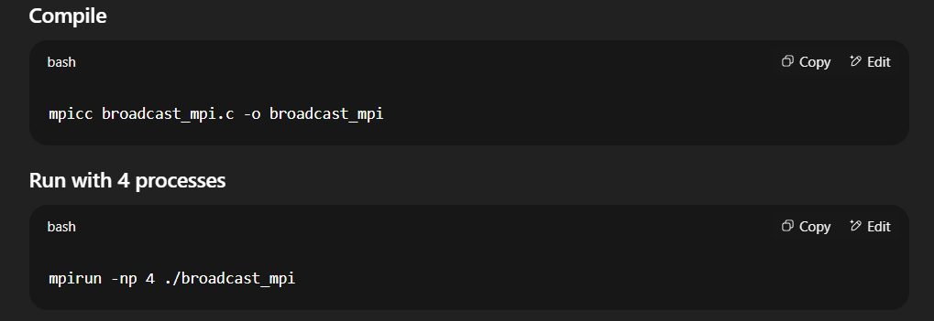

- Program
// scatter_gather_mpi.c
#include <stdio.h>
#include <mpi.h>

int main(int argc, char** argv)
{
int rank, size;
int send_data[4] = {10, 20, 30, 40};
int recv_data;

// Initialize MPI
MPI_Init(&argc, &argv);

// Get rank and size
MPI_Comm_rank(MPI_COMM_WORLD, &rank);
MPI_Comm_size(MPI_COMM_WORLD, &size);

// Scatter: send one element to each process
MPI_Scatter(send_data, 1, MPI_INT, &recv_data, 1, MPI_INT, 0, MPI_COMM_WORLD);
printf("Process %d received: %d\n", rank, recv_data);

// Each process increments the received value
recv_data += 1;

// Gather: collect updated values back to root process
MPI_Gather(&recv_data, 1, MPI_INT, send_data, 1, MPI_INT, 0, MPI_COMM_WORLD);

// Root prints gathered data
if (rank == 0)
{
printf("Gathered data: ");
for (int i = 0; i < size; i++)
printf("%d ", send_data[i]);
printf("\n");
}

MPI_Finalize();
return 0;
}

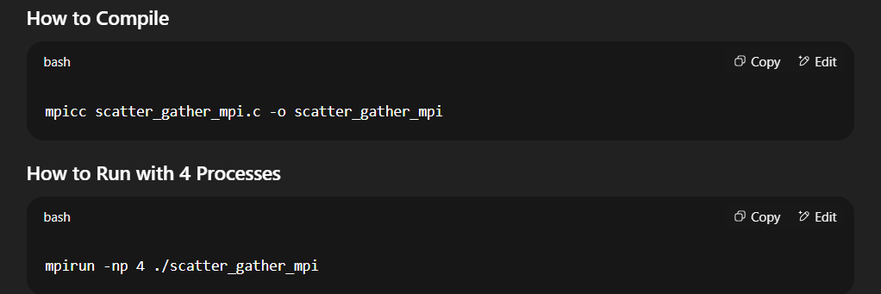

- Program
// reduce_allreduce_mpi.c
#include <stdio.h>
#include <mpi.h>

int main(int argc, char** argv)
{
int rank, value, sum, max;

MPI_Init(&argc, &argv); // Initialize MPI
MPI_Comm_rank(MPI_COMM_WORLD, &rank);

value = rank + 1; // Each process gets a value

// Reduce to find the sum at rank 0
MPI_Reduce(&value, &sum, 1, MPI_INT, MPI_SUM, 0, MPI_COMM_WORLD);
if (rank == 0)
printf("Sum using Reduce: %d\n", sum);

// Allreduce to find the max across all processes
MPI_Allreduce(&value, &max, 1, MPI_INT, MPI_MAX, MPI_COMM_WORLD);
printf("Max using Allreduce (rank %d): %d\n", rank, max);

MPI_Finalize();
return 0;
}
